Seth Cram

ECE341

Lab1 Report

9/14/2021

PIC32 IO cell with external resistors and a button:

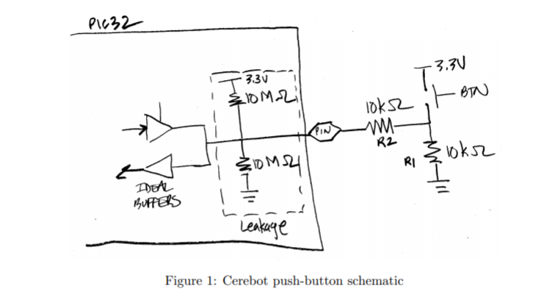

* “Leakage” refers to the effects of leakage current that can influence the voltage seen at the IO pin
* Assume Ideal Buffers configured for an Input operation and no current flows in or out of buffers

Derive expressions and plug values:

Assumption: The pin is ideal and doesn’t have any voltage drop or resistance.

Button’s pressed:

R3 = pull up resistor

R4 = pull down resistor

I0 = current pull up source to pin

I1 = current pin to pull down ground

I2 = current through pin right to left

I0 = (3.3V - Vpin)/(R3)

I1 = (Vpin)/(R4)

I2 = (3.3V - Vpin)/(R2)

KCL at the pin: I0 + I2 = I1

So, (3.3V - Vpin)/R3 + (3.3V - Vpin)/R2 = (Vpin)/R4

Since R3 and R4 are the same, (3.3V - Vpin) + ((3.3V - Vpin)*R4)/R2 = (Vpin)

Simplify: 3.3V + (3.3 * (R4/R2)) = (2 * Vpin) + (Vpin * (R4/R2))

Inputting values: Vpin = 3.297V and I2 = 0.329mA

Button isn't pressed:

R3 = pull up resistor

R4 = pull down resistor

I0 = current pull up source to pin

I1 = current pin to pull down ground

I2 = current through pin right to left

I0 = (3.3V - Vpin)/(R3)

I1 = (Vpin)/(R4)

I2 = -Vpin/(R2+R1)

KCL at the pin: I0 + I2 = I1

So, (3.3V - Vpin)/R3 - Vpin/(R2+R1) = (Vpin)/R4

Since R3 and R4 are the same, (3.3V - Vpin) - (Vpin * R3)/(R2+R1) = Vpin

Simplify: 3.3V = (2 * Vpin) + (Vpin * R3)/(R2+R1)

Inputting values: Vpin = 6.67mV and I2 = -0.329mA

Purpose of external resistors:

R1 exists so that when the button’s pressed not all the current injected into the system is instead drawn to ground, which would happen if a mere wire were there. If R1 was left as an opening in the circuit, the pin would be left floating when it isn’t being written to. R2 exists to most likely decrease the current flowing into the pin for system safety and integrity purposes.

What happens if an input pin doesn’t have a pull-up or pull-down resistor?

The pin would experience a “floating” state far more often. Unused inputs wouldn’t be terminated, so current consumption would increase, causing noise within the processor.

What happens if R1 is removed from the circuit?

If R1 isn’t replaced with a wire, the pin’s left floating because it doesn’t have a path to ground except through leakage. If R1 is replaced with a wire, then when the button’s pressed, all the current injected into the system as an input doesn’t reach the pin and is instead all drawn to ground.

What is the voltage at the IO pin when the button isn’t pressed?

6.67mV as found above.

What effect might this have on software reading that pin?

Referring to the voltage at the IO pin when the button isn’t pressed, the software might have a hard time reading from the pin when the persistence of the button being pressed isn’t very long. This could be remedied by the software using interrupts instead of polling.

Referring to if R1 is removed from the circuit, the software reading that pin could read a 1 or a 0 at any time since the pin’s left floating. If R1 is replaced with a wire instead of just left open, the software would always read a 0 even when the pin should be high. Writing from the software could result in problems in both situations.

Refer to the schematic for the Cerebot 32MX7cK (on the website), page 6.

* LED1-4 are driven directly from an IO pin.
* Assume the IO pin is driving a logic ’1’ (3.3V), and the LED has a 0.7V forward voltage drop.

How much current does the IO pin source in this case?

Assuming the IO pin doesn’t provide any resistance, it sources **5.532mA**. Since 2.6V drops across the resistor and its resistance is 470 Ohms, V/R gives us current through the resistor which is the current through the IO pin.

What is the maximum current that any one IO pin can source or sink?

According to the Cerebot’s absolute maximums, both the maximum current that can be sourced or sunk by any one I/O pin is **25mA**.

What is the total maximum current that can be sourced by all the IO pins?

A total of **200mA** can be sourced by all the IO pins, which is subject to power constraints.